**PROGRAM 6**

**AIM:** Create HTML Page that contains form with fields Name, Email, Mobile No, Gender, Favourite Colour and a button. Now write a JavaScript code to combine and display the information in textbox when the button is clicked and implement validation.

HTML:

<!DOCTYPE html>

<html>

<head>

<title>User Info Form</title>

</head>

<body>

<h2>User Information Form</h2>

<form id="userForm">

<label>Name:</label><br>

<input type="text" id="name" required><br>

<label>Email:</label><br>

<input type="email" id="email" required><br>

<label>Mobile No:</label><br>

<input type="text" id="mobile" required><br>

<label>Gender:</label><br>

<select id="gender" required>

<option value="">Select</option>

<option>Male</option>

<option>Female</option>

<option>Other</option>

</select><br>

<label>Favourite Colour:</label><br>

<input type="color" id="color"><br><br>

<button type="button" onclick="validateAndDisplay()">Submit</button>

</form>

<br>

<textarea id="output" rows="6" cols="50" readonly></textarea>

<script src="script.js"></script>

</body>

</html>

JavaScript:

function validateAndDisplay() {

const name = document.getElementById("name").value.trim();

const email = document.getElementById("email").value.trim();

const mobile = document.getElementById("mobile").value.trim();

const gender = document.getElementById("gender").value;

const color = document.getElementById("color").value;

// Basic validation

const emailPattern = /^[^\s@]+@[^\s@]+\.[^\s@]+$/;

const mobilePattern = /^[0-9]{10}$/;

if (!name || !email || !mobile || !gender) {

alert("Please fill in all required fields.");

return;

}

if (!emailPattern.test(email)) {

alert("Please enter a valid email address.");

return;

}

if (!mobilePattern.test(mobile)) {

alert("Mobile number must be 10 digits.");

return;

}

const outputText =`Name: ${name}

Email: ${email}

Mobile: ${mobile}

Gender: ${gender}

Favourite Colour: ${color}`;

document.getElementById("output").value = outputText;

}

OUTPUT

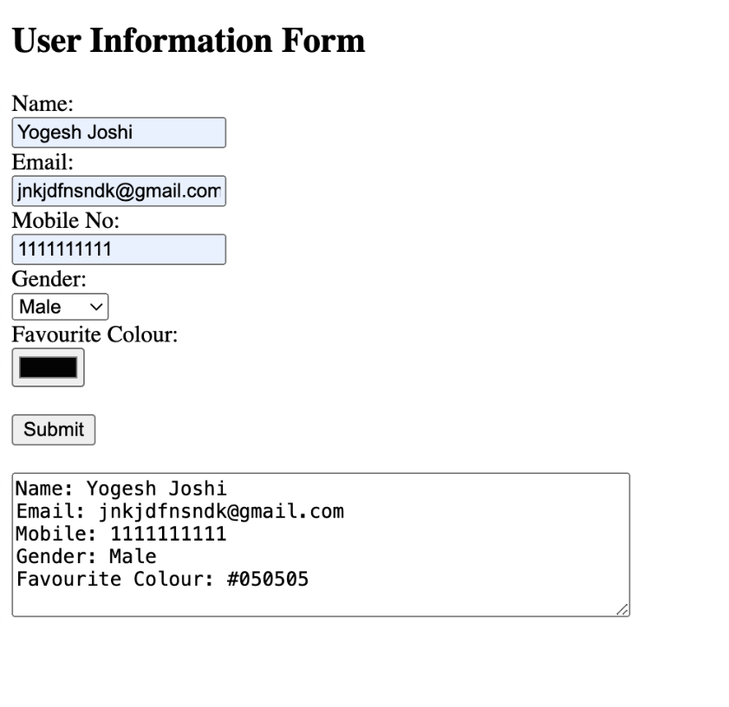

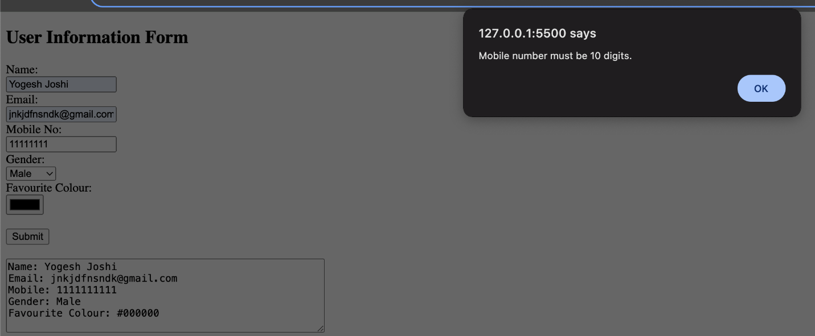

**PROGRAM 7**

**AIM:** Create an XML file to store student information like Enrolment Number, Name, Mobile Number, Email Id.

XML:

<?xml version="1.0" encoding="UTF-8"?>

<students>

<student>

<enrolmentNo>BPIT123456</enrolmentNo>

<name>ABC</name>

<mobile>9876543210</mobile>

<email>abc.jj@example.com</email>

</student>

<student>

<enrolmentNo>BPIT123457</enrolmentNo>

<name>XYZ </name>

<mobile>9123456789</mobile>

<email>riya.sharma@example.com</email>

</student>

<student>

<enrolmentNo>BPIT123458</enrolmentNo>

<name>WQE </name>

<mobile>9012345678</mobile>

<email>kkl.cv@example.com</email>

</student>

</students>

OUTPUT

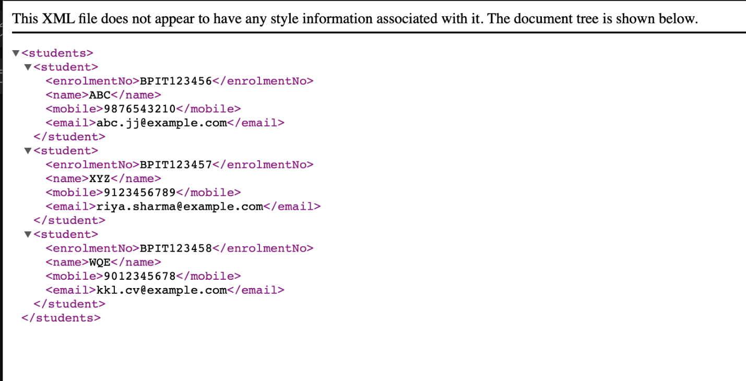

**PROGRAM 8**

**AIM: Write a PHP script to read data from txt file and display it in an HTML table** (The file contains info in format: Name:Password:Email).

PHP:

<!DOCTYPE html>

<html>

<head>

<title>User Data Table</title>

<style>

table {

border-collapse: collapse;

width: 50%;

margin: 20px auto;

}

th, td {

border: 1px solid #555;

padding: 8px;

text-align: left;

}

th {

background-color: #f2f2f2;

}

</style>

</head>

<body>

<h2 style="text-align:center;">User Data from Text File</h2>

<?php

$filename = "userdata.txt";

if (file_exists($filename)) {

$file = fopen($filename, "r");

echo "<table>";

echo "<tr><th>Name</th><th>Password</th><th>Email</th></tr>";

while (($line = fgets($file)) !== false) {

$parts = explode(":", trim($line));

if (count($parts) == 3) {

echo "<tr>";

echo "<td>" . htmlspecialchars($parts[0]) . "</td>";

echo "<td>" . htmlspecialchars($parts[1]) . "</td>";

echo "<td>" . htmlspecialchars($parts[2]) . "</td>";

echo "</tr>";

}

}

echo "</table>";

fclose($file);

} else {

echo "<p style='text-align:center; color:red;'>File not found.</p>";

}

?>

</body>

</html>

OUTPUT

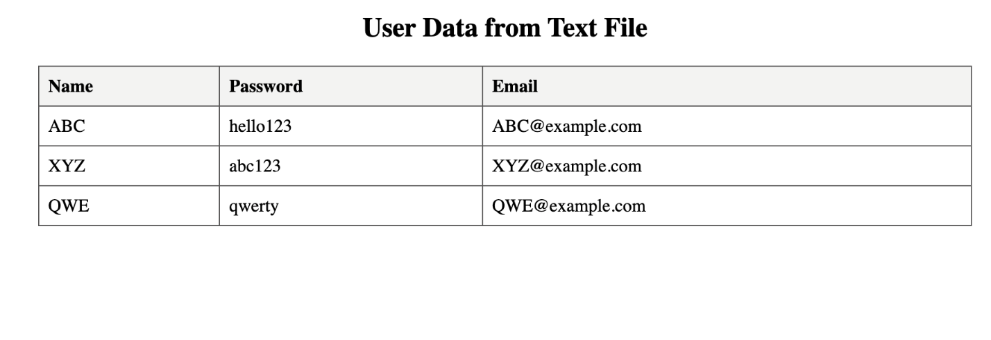

**PROGRAM 9**

**AIM:** Write a PHP Script for login authentication. Design an HTML form which takes username and password from user and validate against stored username and password in file.

PHP:

if ($_SERVER["REQUEST_METHOD"] == "POST") {

$inputUser = $_POST['username'];

$inputPass = $_POST['password'];

$isValid = false;

$file = fopen("users.txt", "r");

if ($file) {

while (($line = fgets($file)) !== false) {

$line = trim($line);

list($storedUser, $storedPass) = explode(":", $line);

if ($inputUser === $storedUser && $inputPass === $storedPass) {

$isValid = true;

break;

}

}

fclose($file);

}

if ($isValid) {

echo "<h3>Login successful! Welcome, $inputUser</h3>";

} else {

echo "<h3>Invalid username or password.</h3>";

}

}

?>

HTML:

<!DOCTYPE html>

<html>

<head>

<title>Login</title>

</head>

<body>

<h2>User Login</h2>

<form action="login.php" method="post">

<label for="username">Username:</label>

<input type="text" name="username" required><br><br>

<label for="password">Password:</label>

<input type="password" name="password" required><br><br>

<input type="submit" value="Login">

</form>

</body>

</html>

OUTPUT

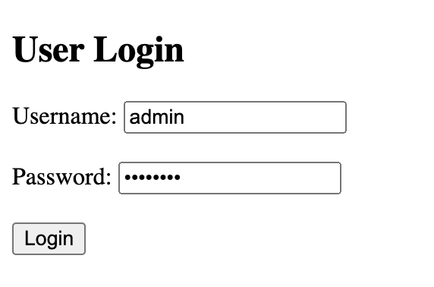



**PROGRAM 10**

**AIM:** Write PHP Script for storing and retrieving user information from MySql table.

a. Design A HTML page which takes Name, Address, Email and Mobile No. From user (register.php)

b. Store this data in Mysql database/text file.

c. Next page display all user in html table using PHP (display.php).

Index.php:

<!DOCTYPE html>

<html lang="en">

<head>

<meta charset="UTF-8">

<meta name="viewport" content="width=device-width, initial-scale=1.0">

<title>User Registration</title>

</head>

<body>

<h2>User Registration</h2>

<form action="store_user.php" method="POST">

<label for="name">Name:</label>

<input type="text" id="name" name="name" required><br><br>

<label for="address">Address:</label>

<textarea id="address" name="address" required></textarea><br><br>

<label for="email">Email:</label>

<input type="email" id="email" name="email" required><br><br>

<label for="mobile">Mobile No:</label>

<input type="text" id="mobile" name="mobile" required><br><br>

<input type="submit" value="Register">

</form>

</body>

</html>

store_user.php:

<?php

// Get data from the form

$name = $_POST['name'];

$address = $_POST['address'];

$email = $_POST['email'];

$mobile = $_POST['mobile'];

// Prepare data to be written into the text file

$data = "Name: " . $name . "\n";

$data .= "Address: " . $address . "\n";

$data .= "Email: " . $email . "\n";

$data .= "Mobile No: " . $mobile . "\n";

$data .= "----------------------------\n"; // Separator for better readability

// Define the file path where data will be stored

$file = 'users.txt';

// Write data to the file

file_put_contents($file, $data, FILE_APPEND);

echo "User registered successfully!";

echo "<br><a href='display.php'>View all users</a>";

?>

display.php:

<?php

// Define the file path where user data is stored

$file = 'users.txt';

// Check if the file exists

if (file_exists($file)) {

// Read the content of the file

$content = file_get_contents($file);

// Display the content in an HTML table

echo "<h2>All Users</h2>";

echo "<pre>" . $content . "</pre>"; // Using <pre> to preserve formatting in the text file

} else {

echo "No user data found.";

}

?>

OUTPUT

